Title: Introduction to Verilog HDL and RTL Design of Basic Combinational Circuits
Intern Name: Lagisetty Vidya Charan
College: Mohan Babu University
Department: Electronics and Communication Engineering
Internship: VLSI Internship – Task 2
Software Used:
- Xilinx Vivado 2025.2
- Verilog Hardware Description Language (HDL)
- Introduction:
Verilog Hardware Description Language (HDL) is one of the most widely used languages for designing and verifying digital circuits. It enables designers to describe hardware functionality using a high-level programming approach while accurately representing digital logic behavior. Register Transfer Level (RTL) modeling is a commonly used design methodology in Verilog, where data transfer between registers and the associated logic operations are described.
In this task, basic combinational circuits were designed using Verilog HDL. The circuits include fundamental logic gates, a Half Adder, and a Full Adder. Each design was verified through behavioral simulation using Xilinx Vivado, ensuring that the outputs matched the expected truth tables.
- Objective:
The objectives of this task are:
- To understand the fundamentals of Verilog HDL.
- To learn RTL modeling techniques for combinational circuits.
- To implement basic logic gates using Verilog.
- To design and simulate Half Adder and Full Adder circuits.
- To verify circuit functionality using behavioral simulation in Xilinx Vivado.
- To analyze simulation waveforms and validate digital logic operations.
- Software Used:
Software | Purpose
Xilinx Vivado 2025.2 | Verilog coding, compilation, and simulation
Vivado Simulator | Behavioural simulation and waveform analysis
Verilog HDL | Hardware Description Language used for circuit implementation
- Verilog HDL Basics:
Verilog HDL is a hardware description language used to model digital electronic systems. Unlike conventional programming languages, Verilog describes hardware structures and their behavior. RTL (Register Transfer Level) modeling represents the flow of digital signals between registers and combinational logic.
The main components used in this task include:
- Module: Represents a hardware block.
- Input ports: Receive external signals.
- Output ports: Produce the output signals.
- Continuous Assignment (assign): Continuously updates the output based on input changes.
RTL modelling provides a simple and efficient approach for designing combinational circuits.
- Logic Gates Design:
Theory:
Logic gates are the fundamental building blocks of digital electronics. Every digital circuit is constructed using combinations of these basic gates.
The following gates were implemented:
- AND Gate: Produces HIGH output only when both inputs are HIGH.
- OR Gate: Produces HIGH output when at least one input is HIGH.
- NOT Gate: Produces the complement of the input.
- NAND Gate: Produces the complement of the AND operation.
- NOR Gate: Produces the complement of the OR operation.
- XOR Gate: Produces HIGH output only when the inputs are different.
Verilog Implementation
The logic gates were implemented as individual Verilog modules using continuous assignment statements.
Logic gates.v:
module and_gate(
input A,
input B,
output Y
);
assign Y = A & B;
endmodule

module or_gate(
input A,
input B,
output Y
);
assign Y = A | B;
endmodule

module not_gate(
input A,
output Y
);
assign Y = ~A;
endmodule

module nand_gate(
input A,
input B,
output Y
);
assign Y = ~(A & B);
endmodule

module nor_gate(
input A,
input B,
output Y
);
assign Y = ~(A | B);
endmodule

module xor_gate(
input A,
input B,
output Y
);
assign Y = A ^ B;
endmodule
Behavioral Simulation
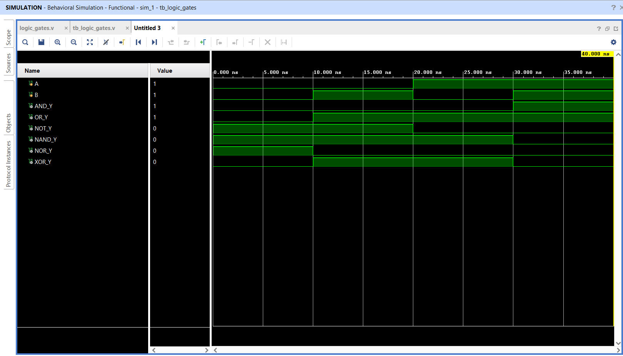
The logic gates were verified using a testbench that applied all possible input combinations. The simulation waveforms confirmed that every gate produced the expected outputs.
Figure 1: Behavioral simulation waveform of basic logic gates

- Half Adder Design;

Theory:
A Half Adder is a combinational circuit used to add two single-bit binary numbers.
It produces two outputs:
- Sum – Represents the addition result.
- Carry – Indicates whether a carry is generated.
The Boolean expressions are:
Sum = A ⊕ B
Carry = A · B
Truth Table:
A | B | Sum | Carry
0 | 0 | 0 | 0
0 | 1 | 1 | 0
1 | 0 | 1 | 0
1 | 1 | 0 | 1

Verilog Implementation:
The Half Adder was implemented using XOR and AND operations in Verilog.

Half_adder.v

module half_adder(
input A,
input B,
output Sum,
output Carry
);

assign Sum = A ^ B;
assign Carry = A & B;

endmodule

Behavioral Simulation

Behavioral simulation verified the correctness of the Half Adder outputs for all input combinations.

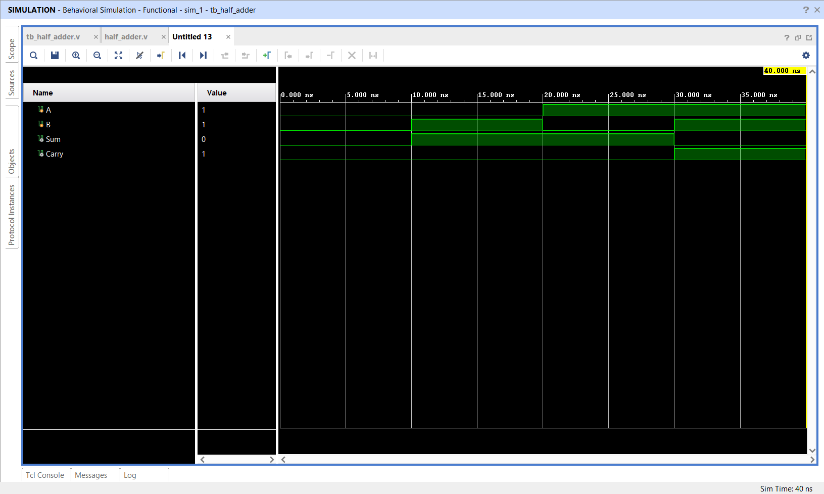
Figure 2: Behavioral simulation waveform of the Half Adder.

- Full Adder Design:

Theory:

A Full Adder is a combinational circuit capable of adding three single-bit binary inputs.
Inputs:
- A
- B
- Carry In (Cin)
Outputs:
- Sum
- Carry Out (Cout)
The Boolean expressions are:
Sum = A ⊕ B ⊕ Cin
Cout = (A · B) + (B · Cin) + (A · Cin)
Truth Table:

A | B | Cin | Sum | Cout
0 | 0 | 0 | 0 | 0
0 | 0 | 1 | 1 | 0
0 | 1 | 0 | 1 | 0
0 | 1 | 1 | 0 | 1
1 | 0 | 0 | 1 | 0
1 | 0 | 1 | 0 | 1
1 | 1 | 0 | 0 | 1
1 | 1 | 1 | 1 | 1

Verilog Implementation:
The Full Adder was implemented using XOR, AND, and OR operations in Verilog

Full Adder.v

module full_adder(
input A,
input B,
input Cin,
output Sum,
output Cout
);
assign Sum = A ^ B ^ Cin;
assign Cout = (A & B) | (B & Cin) | (A & Cin);
endmodule
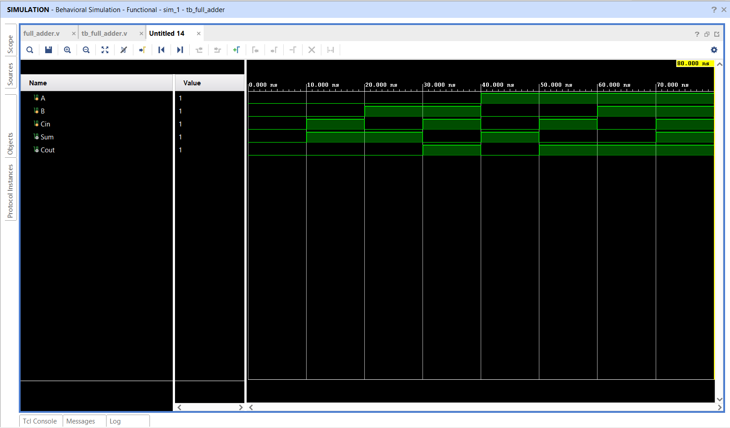
Behavioral Simulation

- Simulation Results

Behavioral simulations were performed for all implemented circuits using Xilinx Vivado Simulator.
The observed outputs matched the expected truth tables for:
- Basic Logic Gates
- Half Adder
- Full Adder
The simulation waveforms confirmed the correctness of the implemented Verilog modules under all possible input combinations
- Learning Outcomes:

After completing this task, the following concepts were learned:
- Fundamentals of Verilog HDL
- RTL modelling of combinational circuits
- Creation of Verilog modules
- Continuous assignment using assign
- Testbench development for simulation
- Behavioral simulation using Xilinx Vivado
- Verification of digital circuits using waveform analysis
- Implementation of arithmetic circuits such as Half Adder and Full Adder

- Conclusion:

This task provided practical experience in designing and verifying basic combinational circuits using Verilog HDL. Logic Gates, Half Adder, and Full Adder were successfully implemented using RTL modeling and tested through behavioral simulation in Xilinx Vivado. The simulation results matched the expected truth tables, demonstrating the correctness of the implemented designs. This assignment strengthened the understanding of digital logic design, hardware description languages, and simulation-based verification, which are fundamental concepts in VLSI design and FPGA development.

